**Microprocessor Lab**

Laboratory Activity No. 1

**Familiarization with TinkerCAD**

|  |
| --- |
|  |

Score

*Submitted by:*

**Espeña, Leonard P.**

**<Sat. 1:00PM-4:00PM> / <CPE 0412.1-2>**

*Date Submitted*

**16-09-2023**

*Submitted to:*

**Engr. Maria Rizette H. Sayo**

1. Exercise

a. A process in Tinkercad where we can develop electronic circuits that can be quickly updated, modified and tested is called Breadboarding.

b. In Tinkercad, Simulation tests the working of the circuits and the components.

c. The device used to assemble and connect the various components is known as Breadboard.

d. In an electronic circuit with LED, the positive end of the circuit should be connected to

Anode, and negative end should be connected to Cathode of the LED.

e. A Resistor is used to restrict the flow of current to electrical components



2. Label the following:

1. Anode and Cathode in a LED Cathode Anode

* The anode, often known as the positive side of the LED, is distinguished by having a longer lead, or leg. The cathode is the other, negative side of the LED.

1. Different parts of breadboard

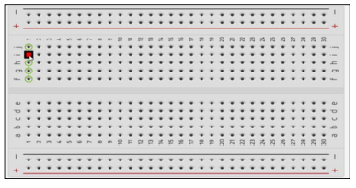

Edge



Main Area



Edge

1. List the electronic components used in a circuit assembly

* Digital I/O:

• Arduino Uno R3

• Breadboard

• LED

• Resistor

• Wires

Analog I/O:

• Arduino Uno R3

• Breadboard

• LED

• Resistor

• Wires

• Potentiometer